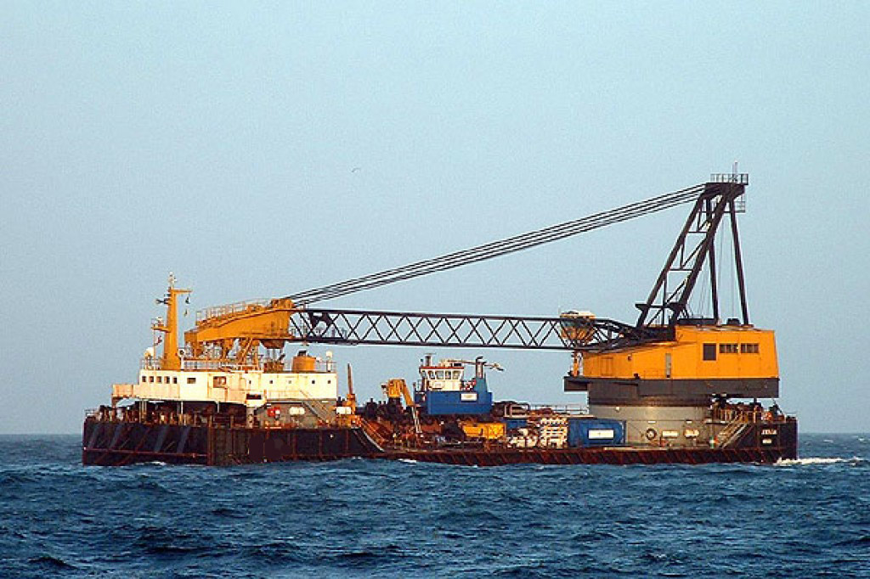

The main crane, PHB, is a stern mounted gantry derrick crane with a lifting capacity of 350 metric tons A model PHB, hydraulically operated gantry / derrick crane with 178’ of boom and rated at 350+
metric tons was
installed atop a pedestal aft at centerline. The crane operated independently of
all other barge systems.

Prime
Mover:
Caterpillar, model D399, turbocharged, intercooled, 990 bhp /

North American Marine Consultants, LLC Current Fair Market Value estimate equals $11,250,000 based on survey conducted January 16, 2015.
Rivers & Gulf Marine Surveyors Current Fair Market Value estimate
$ 14,000,000.000 based on survey conducted July 30, 2012

